**10. Practical Example 1: Swing GUI for CRUD Operations**

1. **Introduction to Java Swing for GUI development**

* Java Swing is a powerful GUI (Graphical User Interface) toolkit for Java. It is part of the Java Foundation Classes (JFC) and provides a set of GUI components to build interactive desktop applications. Swing is built on top of the older AWT (Abstract Window Toolkit), but it offers more features, flexibility, and a richer set of controls.

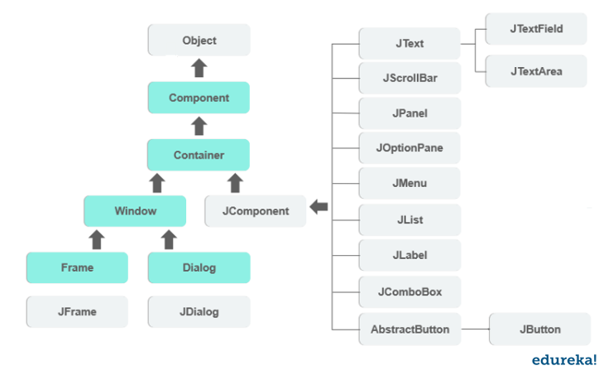

1. **How to integrate Swing components with JDBC for CRUD operations:-**
2. **Create Swing GUI components**: Design the UI using Swing components (e.g., buttons, text fields, tables) to interact with the user.
3. **Set up JDBC connection**: Before performing CRUD operations, you need to establish a connection to the database.
4. **Implement event handling**: Use event listeners (like ActionListener for buttons) to handle user interactions and trigger the appropriate CRUD operations.
5. **Perform CRUD operations**: Use SQL queries to interact with the database based on the user input.